|  |  |  |  |
| --- | --- | --- | --- |
| Year 12 Worksheet 1 – Formative Assessment 2 | | | |
|  | | | |
| **Name:** | **Teacher:** | **Score /5** | |
| **Comment:** | | | **Time allowed:**  **15 minutes** |

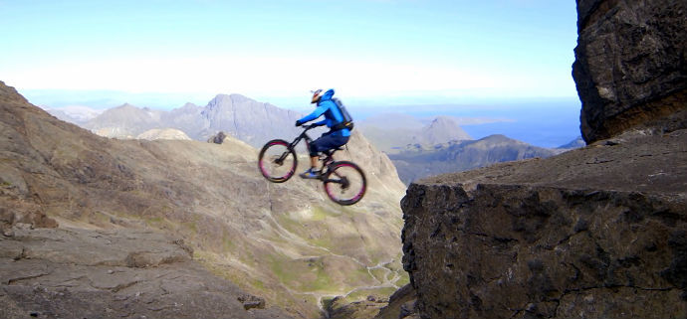

1. An extreme sports BMX rider cycles horizontally off the edge of a edge of a 7.50 m high cliff face. If his initial velocity is 7.50ms-1, how long will the rider be in the air and how far will he jump away from the cliff?

|  |  |
| --- | --- |
| $$s=ut+\frac{1}{2}at^{2}$$ $$7.5=0+\frac{1}{2}9.8 t^{2}$$ $$t^{2}=1.5306$$ $t=1.24 s$ (1) | $$s=v x t$$ $$s=7.50 x 1.237$$ $s=9.27m$ (1) |

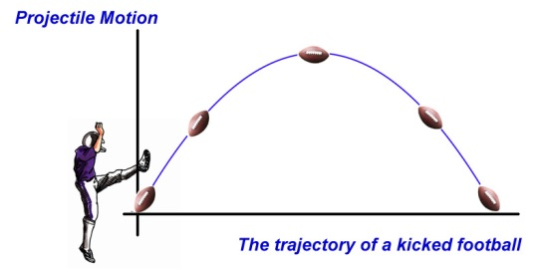

1. A football is kicked at 25 ms-1 from ground level at an angle of 30 degrees. (Use the space on back of page if you need it)
2. At what time will the ball reach its maximum height?
3. What is its maximum height?
4. What is the balls speed if it is caught 1.00 m above ground level?

|  |  |  |
| --- | --- | --- |
| uv = 25sin30 = 12.5 ms-1  vh = 25cos30 = 21.65 ms-1  a = -9.80 ms-2 | (1) | (1) |

|  |  |  |
| --- | --- | --- |
| uv = 25sin30 = 12.5 ms-1  vh = 25cos30 = 21.65 ms-1  a = -9.80 ms-2 | KE launch = PE + KE @ 1m $${\frac{1}{2}mu}^{2}=mgh+{\frac{1}{2}mv}^{2}$$ $${\frac{1}{2}25}^{2}=9.80x1+{\frac{1}{2}v}^{2}$$ $$312.5=9.80+{\frac{1}{2}v}^{2}$$ $$302.7={\frac{1}{2}v}^{2}$$ $$v^{2}=605.4$$ $v=24.6 ms^{-1}$ (1) | $$OR using components$$ $$v^{2}=u^{2}+2as$$ $$v^{2}={12.5}^{2}+2x- 9.80 x 1$$ $$v^{2}=156.25-19.6$$ $v^{2}=156.25$ $$v =11.68 ms^{-1} (down)$$ Vector sum (Pythagoras) $${spd}^{2}={11.68}^{2}+{21.65}^{2}$$ $${spd}^{2}=605.4$$ $speed =24.6 ms^{-1}$ (1) |